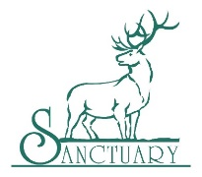
Please Click Name for Additional Information
Navy SEAL Foundation
Big Brothers Big Sisters
Anchor Center for Blind Children
Springs Rescue Mission
Raise the Future
National Jewish Health
Arrupe Jesuit High School
The Foundation Fighting Blindness, Inc.
Hope House of Colorado
Colorado State Patrol Family Foundation
AIMCO Cares
Warrior Wellness Foundation/ Remount Foundation
Children's Hospital
Food Bank of the Rockies
Craig Hospital Foundation
Project C.U.R.E.
Volunteers of America
Tennyson Center for Children
Boys & Girls Clubs of Metro Denver, Inc.
Mt. Carmel Veterans Service Center
Junior Achievement
Energy Outreach
Special Forces Foundation
Boy Scouts of America, Denver Area Council
Rocky Mt. Adventist Healthcare Foundation-Castle Rock Adventist Hospital (CRAH)
Steadman Philippon
Flight for Life--St. Anthony Health Foundation, Catholic Health Initiatives

