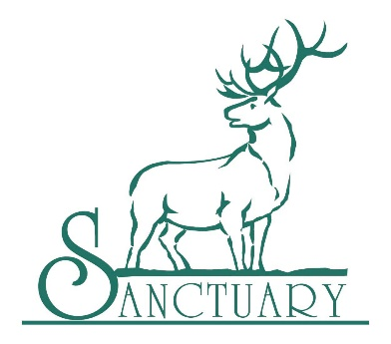
Navy SEALS Foundation
Anchor Center for Blind Children
Springs Rescue Mission
Raise the Future
National Jewish Health
Arrupe Jesuit High School
Foundation Fighting Blindness
Big Brothers Big Sisters of Colorado
Hope House of Colorado
Colorado State Patrol Family Foundation
AIMCO Cares
Warrior Wellness Foundation
Children’s Hospital
Craig Hospital
Project C.U.R.E.
Mt. Carmel Veterans Service Center
Volunteers of America
Tennyson Center for Children
Boys and Girls Clubs of Metro Denver
Food Bank of the Rockies
Junior Achievement
Energy Outreach Colorado
Boys Scouts of America
Castle Rock Adventist Hospital Foundation
Steadman Philippon Research Institute
Special Forces Foundation
Flight for Life

